Contemporary Issue Management Assignment PART A
PART A: MGMT-8760 – Contemporary Issue Identification & Team Contract (10% of Course Grade
BE SURE TO WATCH THE RECORDED INSTRUCTIONS AND REVIEW THE RUBRIC TO ENSURE YOU ARE INCLUDING ALL OF THE REQUIRED ELEMENTS IN YOUR WORK.
Complete all sections of the Issue Identification & Team Contract below: (10 Marks)
Team Member’s Name
A

B

C

D

E
F
Team Name

Contemporary Issue Identification:

For the first section your team must identify and agree upon a contemporary (modern) organizational behaviors issue/concern you will study and resolve for your organization.

Begin by doing some research to discover what modern issues exist in organizations today There are very few limitations—your team could select almost anything that is related to workplace behaviors. There is a possibility that your Professor will redirect
your selection if it is felt that there would not be enough information available on the topic a team initially selects.

Topics Include (But are not limited to):

- Employee Recognition/Reward Programs
- Social Media Policy in the Workplace
- Work-Life Balance
- Effective Use of Technology
- Promoting Positive Organizational Citizenship Behaviors
- Bullying in the Workplace
- Workplace Harassment
- Whistleblowing
- Diversity in the Workplace

Our Topic Is: Bullying In The Workplace (1 Mark)

Describe why your team chose this topic (be specific & detailed): (5 Marks)

The topic of workplace harassment was chosen by our team for several reasons:

- The importance of the problem: Workplace harassment is a serious issue that has an impact on people and organizations in a variety of professions and industries. It has significant effects on workers' productivity, happiness at work, and general well-being. Promoting safer and more inclusive work settings depends on increasing awareness of this problem and comprehending its effects.

- Supporting victims and potential targets: By talking about workplace harassment, we intend to give people who have gone through or are going through harassment assistance and resources. It is essential to establish a secure environment where victims can receive counselling, learn about their legal options, and report and seek remedy.

- Legal and moral ramifications: Employers that fail to confront and stop workplace harassment may face legal repercussions. Workplace harassment not only harms employees' well-being. By talking about this subject, we may clarify the legal foundation for workplace harassment, including anti-discrimination regulations, policies, and practices.

- Promoting a culture of respect in the workplace: By addressing the issue of workplace harassment, we hope to advance a climate of decency, equality, and fairness. It is crucial to inform people about what constitutes harassment and give them the tools they need to act to stop and stop such behavior.

Provide 4-5 resources your team used to research your topic (site name & URL): (4 Marks)

1. McDonalds (https://sbc.mcd.com/our-conduct#discrimination-and-harassment)
2.Equal Employment Opportunity Commission (EEOC) - www.eeoc.gov
3. Navex Global - www.navexglobal.com
4. Employment Law Handbook - www.employmentlawhandbook.com
5. Canadian Human Right Commission - www.chrc-ccdp.gc.ca

TEAM CONTRACT:
Now that you have selected a topic you need to think about how you plan to complete the assignment as a team. As you will learn in upcoming modules there is a difference between Groupwork vs Teamwork. To get you to collaborate and benefit from teamwork you will now fill out a contract that starts with establishing team goals, rules & an initial plan for your contemporary issue report & presentation (Parts B & C).
Expectations of Team Members
- Be accountable for tasks/assignments.
- Complete work on time and correctly
- Listen to each other, the team leader, and the professor.
- Give and get respect.
- Make a fair contribution to the final product.
- Let the team leader know about absence before team meetings.
- Make your best effort.
- Ask for assistance if unsure.

Goals for the Issue Report are: (3 marks)
1. Examine Organizational Policies and Practices: Analyze organizational policies and practices to find ways to promote a respectful, diverse, and harassment-free culture
.
2. Promote Bystander Intervention, foster a Culture of Speaking Up, and Empower Employees: Recommend strategies to empower employees through thorough and ongoing training programs.

3. Foster Diversity and Inclusion: Analyze the company's attempts to create an inclusive and diverse workplace. Give advice on how to improve the diversity of hiring practices, develop inclusive policies and practices, and encourage cultural sensitivity and competency among employees.

Team Rules: (3 marks)
1.

2.

3.

Initial Workload Plan: (Complete the missing information, you may add extra lines to create a more detailed plan) (3 marks)
A: - Contract formation, Group Coordination, Recommendations
B:
C:
D:
E: Submit finished report & presentation into the Submissions folder by the required deadline
Be sure to consider final editing and reviewing your submissions when discussing deadlines.
Group Meetings (You may assign various members to coordinate and record your meetings)
Group Meetings will be planned according to schedules, but it will be expected that group members will attend, be on time, and contribute to them. _________ will be responsible for recording the Meeting Minutes such as attendance, how workload is divided, internal deadlines and other relevant details.
Consequences for Non-Performance (You may amend or adopt new consequences as approved by your team)
- First Offence -Team will issue a warning. Professor must be made aware that a warning was issued. Members receive a mark of zero for that part.
- Second Offence -Team members will be removed permanently from the group. The team will notify the Professor prior to permanent removal.
- If removed, we will recommend the Professor award a mark of zero for the whole project.

THESE TERMS ARE AGREEABLE TO: (Type your names or add ‘e-signatures’)
__________________________ _________________________ _______________________
__________________________ _________________________ (1 Mark)
Total = 20 Marks

Part A is worth 10% of your total course grade. You must submit on time so be sure to pay attention to the course deadlines.

Rubric: Team Contract & Contemporary Issue Assignment
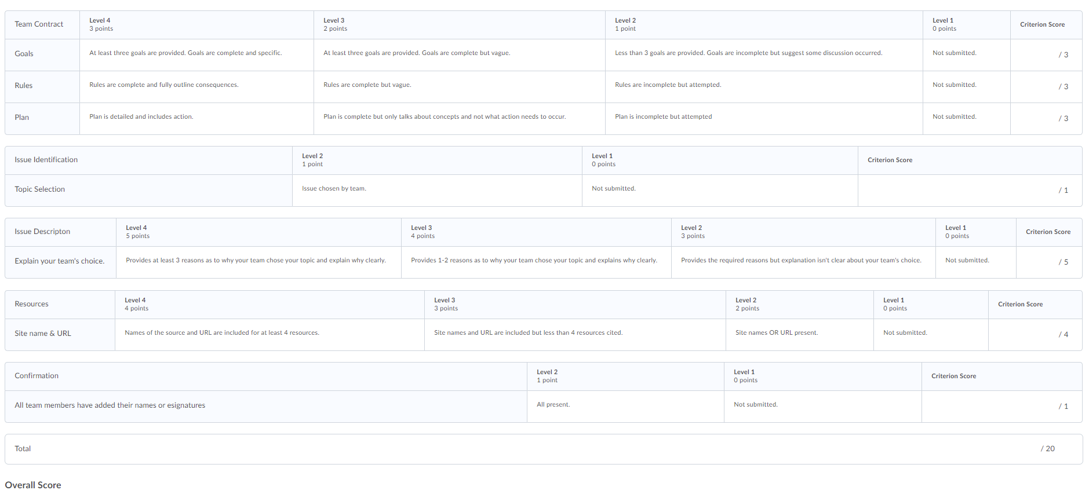

Links to the rubrics can be found using the following path in eConestoga:

Content-Evaluations-Rubrics: select the individual rubric

